|  |  |
| --- | --- |
| **Server & Cloud Security**  Diploma in CSF/IT  Oct 2022 | Week 1 |
| Practical |
| **Practical: Deploying Windows Servers** | |

## **Scenario**

In this activity, you will setup 2 Windows Server 2019 virtual machines namely, DC1 and MS1. DC1 will be the domain controller and MS1 will be the member server in your virtual environment.

## **Objectives**

This activity is designed to test your understanding of the Server OS, virtual networking, Active Directory domains and disk management.

## **Preparation:**

Download Windows Server 2019 image from the below SharePoint link:

(You may also directly copy the image from the lab machines)

<https://connectnpedu.sharepoint.com/:u:/s/CSF.SCS/EcPff97HdTpDrznPN3H52McBvfhCJ5AyLtBSZ5CifWiF5w?e=z6Baa1>

Download VMWare Workstation 16 installer from the below link:

(You may skip this step if your computer already has VMWare Workstation installed, or if you prefer to use Virtual Box)

https://drive.google.com/file/d/1EeKuZA0uNhr9Qtuwro9CCe_ADTP238CL/view?usp=sharing

**Task 1: VMware Workstation 16 Installation**

Run the installer file to install VMware Workstation 16 on your computer. Accept all the required user agreement to use this software for 30 days’ trial.

**Task 2: Create TWO Windows Server 2019 VMs**

Install 2 Windows Server 2019 virtual machines in your virtual environment.

You may skip the step when asked for Windows product key, after you put in your user name, you may click “Next”.

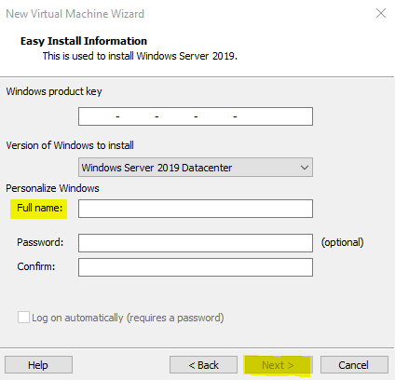

One Windows Server 2019 will be served as the domain controller, you can name it as “**DC1**”. The second Windows Server 2019 will be the member server in the network, you can name it as “**MS1**”. The rest parameters such as location, allocated disk size and etc. can be decided by yourself.

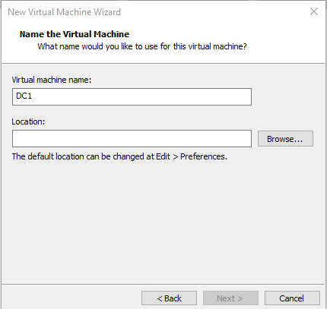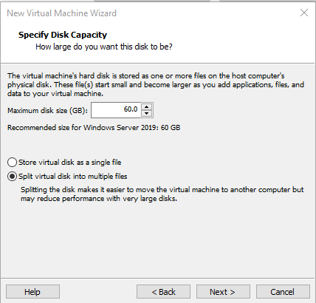

**Task 3: Setup Host-only Network**

Right click the DC1 and MS1 VMs you just created, click “Settings” and then make sure the network connection is using “Host-only”.

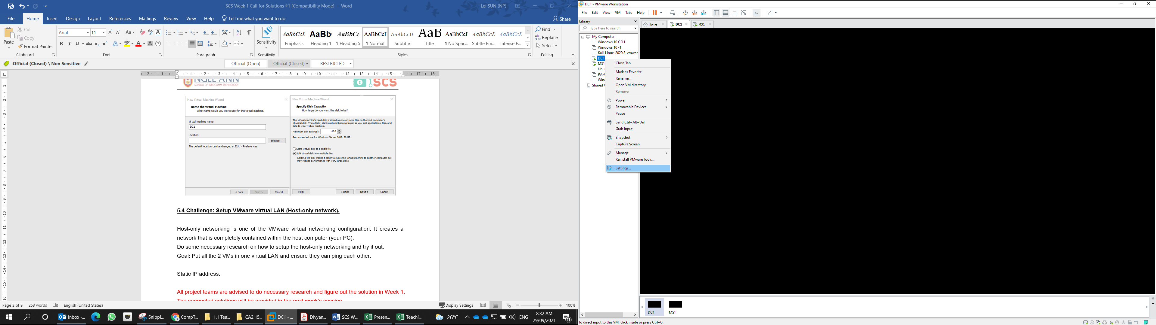 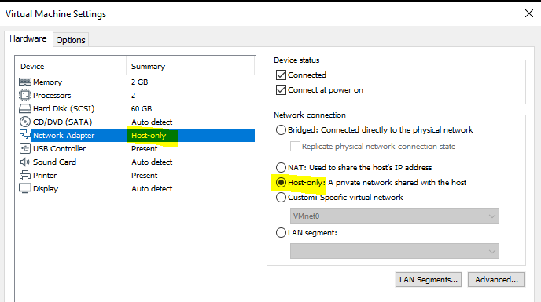

Power on both VMS and use “Command Prompt” to find out the IP address allocated to them.

Without changing the network ID, configure the 2 VMs with static IP addresses and then ensure they can ping each other (you may need to turn off the Windows Firewall).

**Task 4: Configure DC1 Server Roles**

From the Server Manager of DC1, click “Manage” 🡺 “Add Roles and Features”, and then select “Active Directory Domain Services”. This will configure the DC1 server as the Microsoft Active Directory Domain Controller.

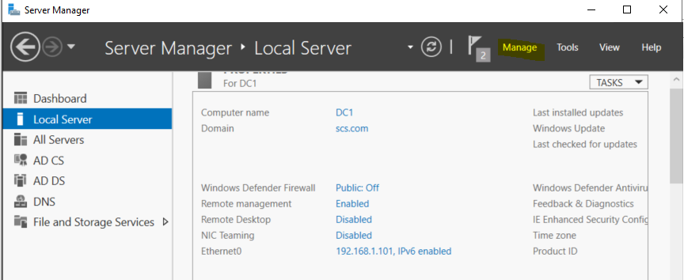

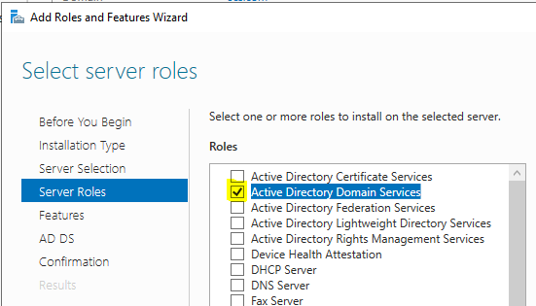

Accept the rest default settings to complete the “Add Roles and Features Wizard”, and lastly, click “Promote this server to a domain controller”.

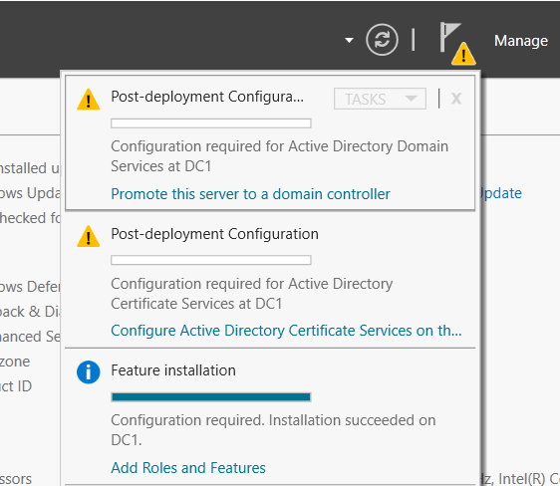

You can configure a new forest and set a name for your domain, such as **scs.com**.

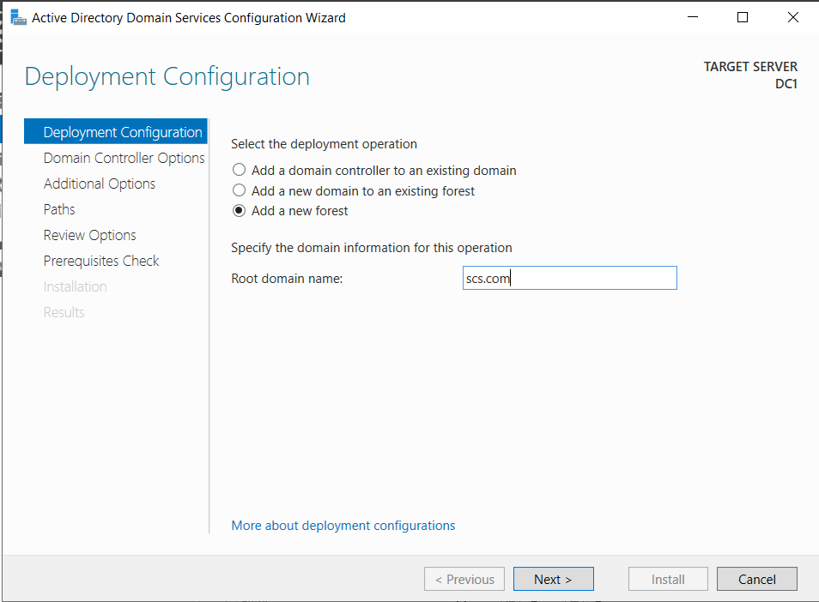

Accept the rest default settings by clicking “Next” multiple times. If you face the below error, which indicating your Administrator has no password, you may need to go to the Control Panel to set a strong password for the Administrator account first.

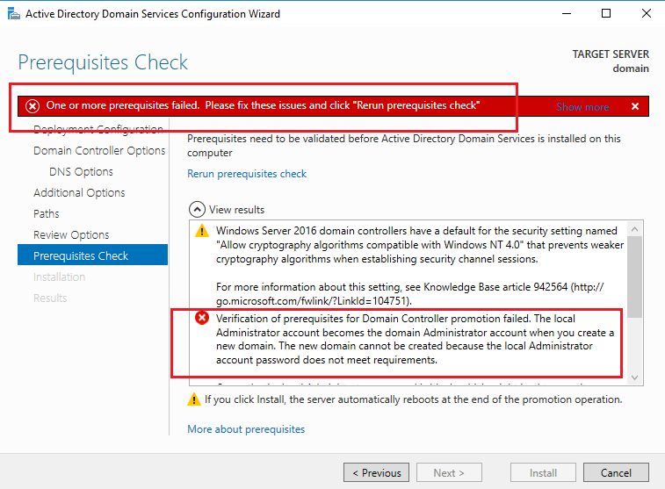

**Task 5: Configure MS1 Server Roles**

Use the same method you have tried in Task 4, now you need to configure your MS1 server to be the web server, by adding the role “Web Server (IIS)” to it.

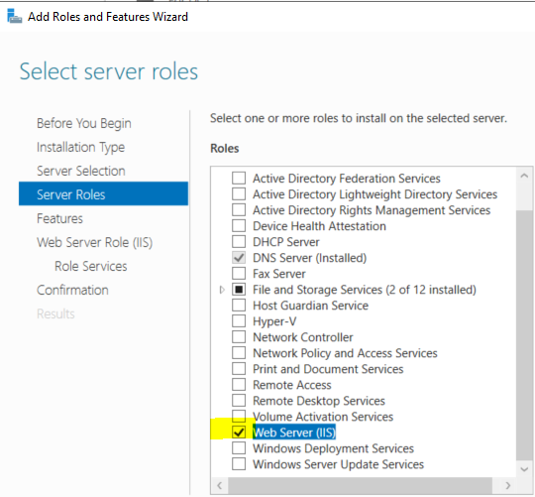

Complete all the steps by your own, and make sure you can see the IIS role on the MS1 Server Manager’s dashboard similar to the below.

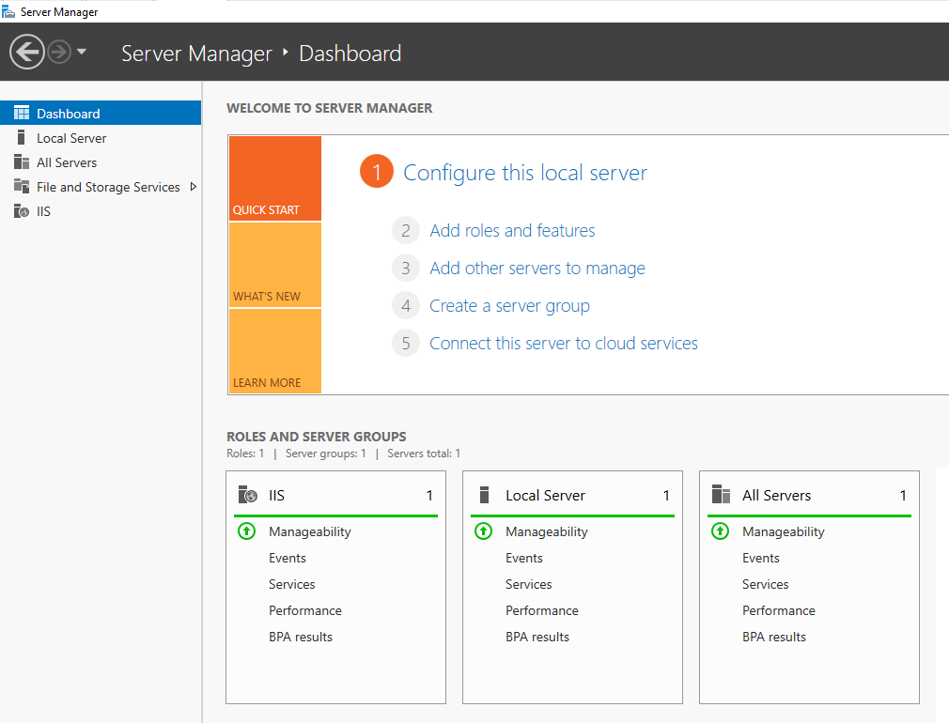

**Task 6: Join MS1 to the Domain**

Now you have DC1 as the domain controller and MS1 as the web server in your network. Next, you need to join MS1 to the domain you have created in Task 4.

To start, from MS1 server, make sure the DNS server’s IP address is set as the IP address of your DC1 server.

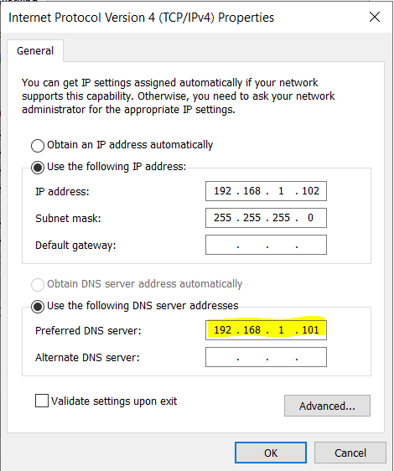

The static IP address of DC1

The static IP address of MS1

Next, access the System information and click “Change settings”.

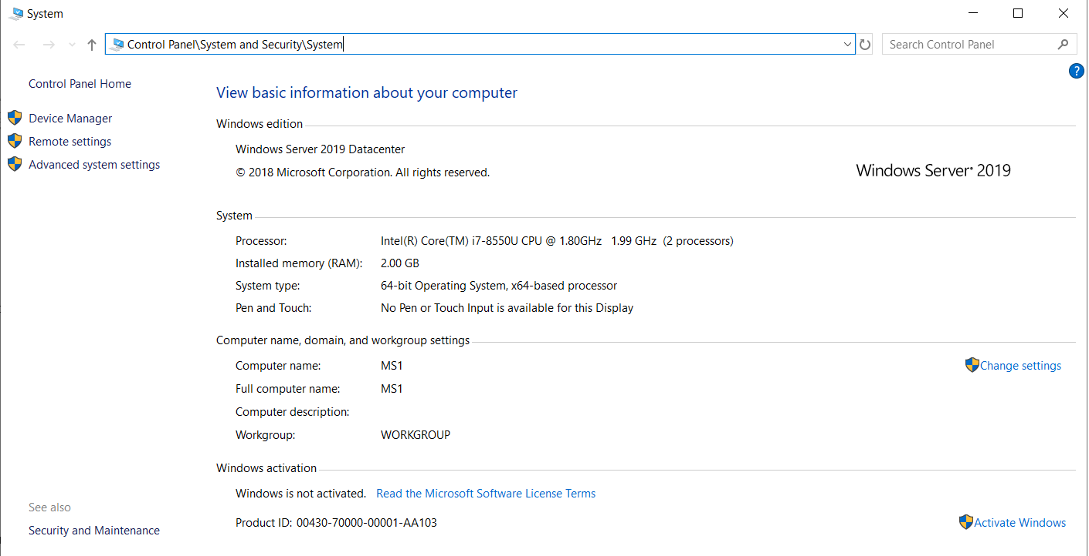

Click “Change” again. Choose “Domain” instead of “Workgroup” and key in your own domain name. You need to key in your Administrator password to proceed.

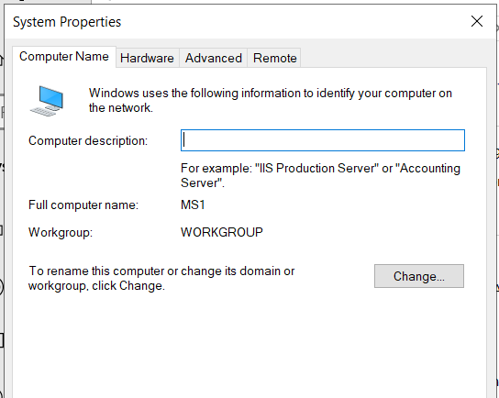

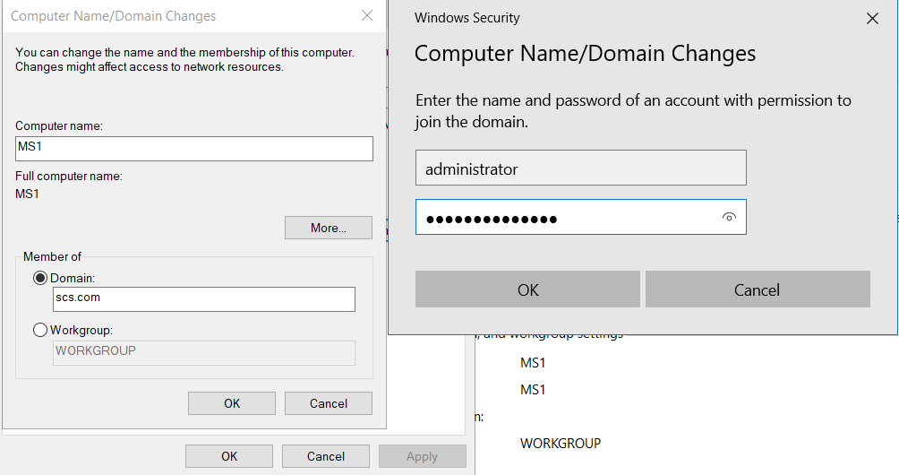

**Task 7: Configure Disk Management for MS1**

Right Click “Windows” icon and select “Disk Management”. Shrink the volume of C: drive and create a new volume. The size of the new volume depends on the space of your VM, a few GB is good enough.

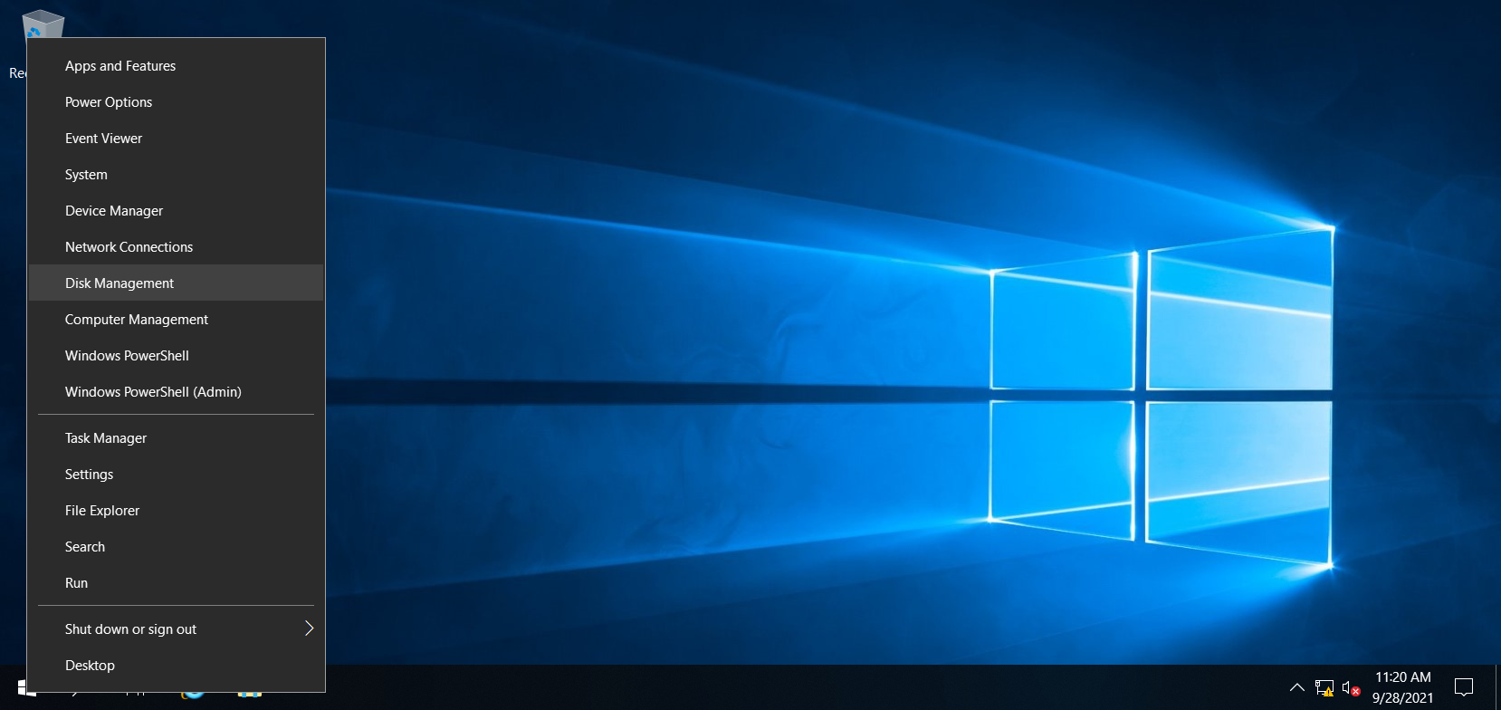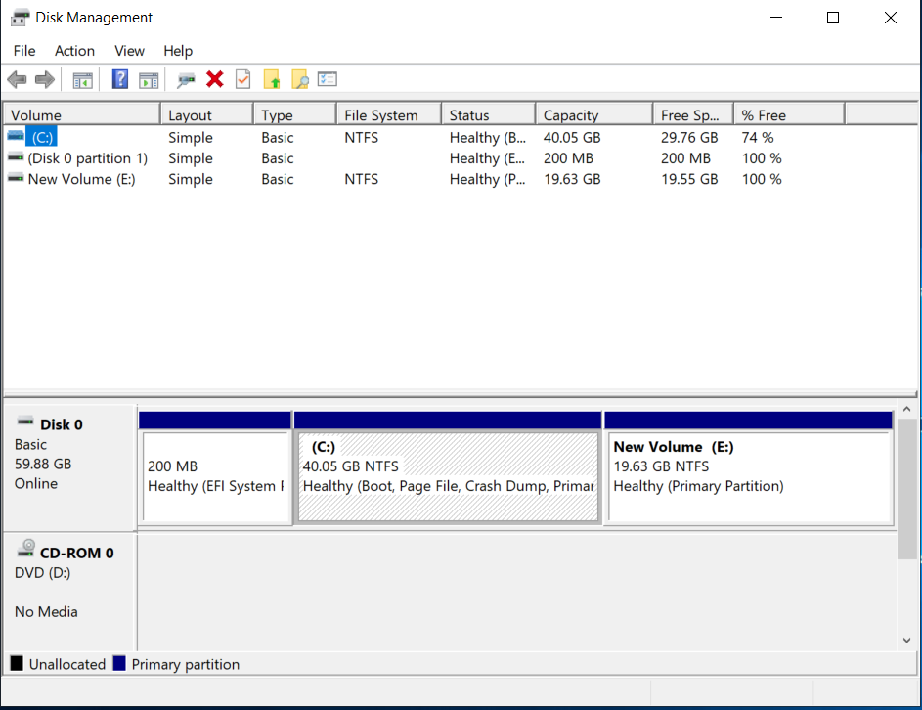

- The End -